**Project Proposal- Itai Assraf- voting with turnout**

**Background:**

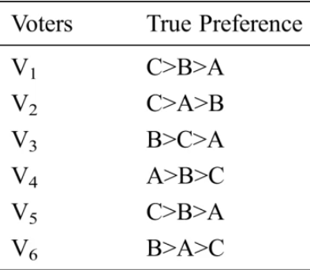Human behavior in voting polls often reveals complex patterns driven by both personal preferences and strategic considerations. Voters may engage in strategic voting, where they do not necessarily vote for their top-preferred candidate but rather for a candidate they believe has a better chance of winning, based on available information such as pre-election polls. This behavior can be influenced by vario0us factors, including the perceived accuracy of the polls, the importance of the election outcome, and the voter's understanding of the voting system. Additionally, psychological factors such as risk aversion, social influence, and the desire to avoid wasting their vote also play significant roles in shaping voting behavior. The study of these behaviors provides valuable insights for designing systems that can predict and support human decision-making in electoral contexts.

**Figure 1: An example of voting poll with 3 candidates**

**Related Work:**

The article investigates human behavior in online voting scenarios through two interactive voting games designed to isolate voters' preferences and available information. The methodology involves both one-shot and iterative voting games, with participants voting based on dictated preferences and varying levels of poll information.

Key findings reveal distinct voting behaviors, including a significant proportion of strategic voting where participants vote for their second-preferred candidate if their top choice is unlikely to win. Rewards for participants were structured to incentivize accurate representation of preferences, with monetary bonuses linked to the performance of chosen candidates.

The study highlights the complexity of strategic voting and provides insights into how such behaviors can inform the design of multi-agent systems for predicting and supporting human decision-making in elections.

["A Study of Human Behavior in Online Voting". Maor Tal, Yaakov Gal, Reshef Meir]

**Extension of the study:**

This study extends prior research on voting behavior by introducing a new experimental condition wherein participants have the option to abstain from voting. In the original experiment, participants received payment based on their selected candidate. However, in this extension, participants can opt not to vote and instead receive a guaranteed payment. The study investigates various values for abstaining from voting and analyzes their impact on participant behavior. Drawing inspiration from previous literature, this study aims to shed light on the dynamics of voting decisions when individuals have the option to abstain.

**Research Question:**

1. How does the introduction of the abstention option affect overall voter turnout?

2. What are the factors influencing participants' decisions to abstain from voting or to cast a ballot for a specific candidate?

3, How do varying levels of guaranteed payment for abstention influence participant behavior and voting outcomes?

4. To what extent does strategic voting behavior persist in the presence of the abstention option, and how does it differ from traditional voting scenarios?

**Research Hypothesis:**

1. Introducing the option to abstain provides participants with an alternative to voting, potentially leading some individuals to opt out altogether, especially if they perceive none of the available candidates align with their preferences or if they perceive their vote as inconsequential. **Thus, the availability of the abstention option is likely to reduce overall voter turnout.**

2. Participants will be more likely to abstain from voting when their top-preferred candidate has a low perceived chance of winning, while strategic voting will occur when participants perceive a higher chance of their preferred candidate winning. **Participants face a trade-off between voting based on their true preferences and voting strategically to maximize the chance of their preferred candidate winning**. When individuals perceive their preferred candidate as unlikely to win, they may choose to abstain rather than "waste" their vote, aligning with their preferences. Conversely, when participants perceive a higher chance of their preferred candidate winning, they may strategically cast their vote to maximize the likelihood of their candidate's success.

3. Higher levels of guaranteed payment for abstention will lead to an increase in the rate of abstention among participants compared to lower levels of guaranteed payment. **Higher levels of guaranteed payment increase the attractiveness of abstention, as participants may prioritize the guaranteed reward over the uncertain outcome associated with voting for a candidate.**

4. Strategic voting is a common phenomenon observed in electoral contexts, driven by individuals' desire to influence the outcome of the election. Even in the presence of the abstention option, participants may engage in strategic voting behavior, particularly if they perceive that their vote can sway the outcome in favor of a preferred candidate. **Thus, strategic voting is anticipated to persist despite the availability of the abstention option.**

**Experiments**:

The preliminary stage of the experiment involves creating a web interface where participants can answer surveys. Before the participants begin, we will provide comprehensive training with a detailed explanation of the experiment's course.

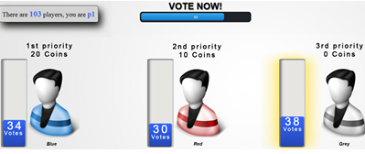In the first stage, participants will see a picture showing how much they will earn (the utility) if they choose each candidate, including the option of earning without choosing any candidate. Additionally, they will see the distribution of votes for each candidate.

Figure : The utility of choosing a candidate, along with the distribution of choices among candidates.

We will run the experiment for 32-36 rounds, during which the following parameters will vary:

1. The benefit of choosing a candidate.
2. The distribution of votes among the candidates.
3. The benefit of choosing not to select any candidate.

This design will allow us to observe changes in participant behavior under different conditions and to identify interesting patterns and behavioral conclusions.